Phase 1 Test Cases
Test 1:
Test Case | Description | Expected Result
Stack Push/Pop sequence | Push 3 items, pop 2 | Final size = 1, with LIFO order maintained

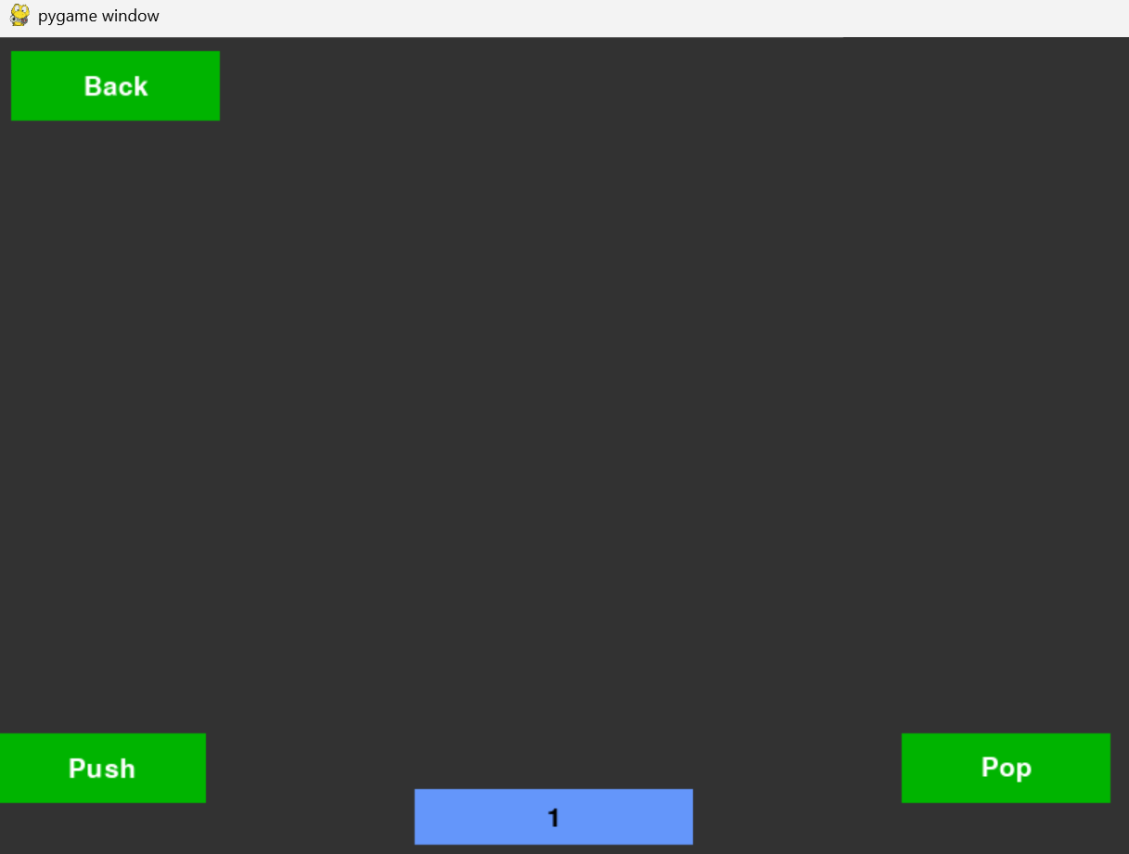
App Testing of: Stack Visualisation

Python Unit Test (test_phase_1_stack):
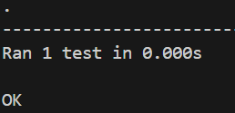

Test 2:
Test Case | Description | Expected Result
Queue Enqueue/Dequeue | Enqueue 4 items, Dequeue 3 items | Final array = [4], with FIFO order maintained

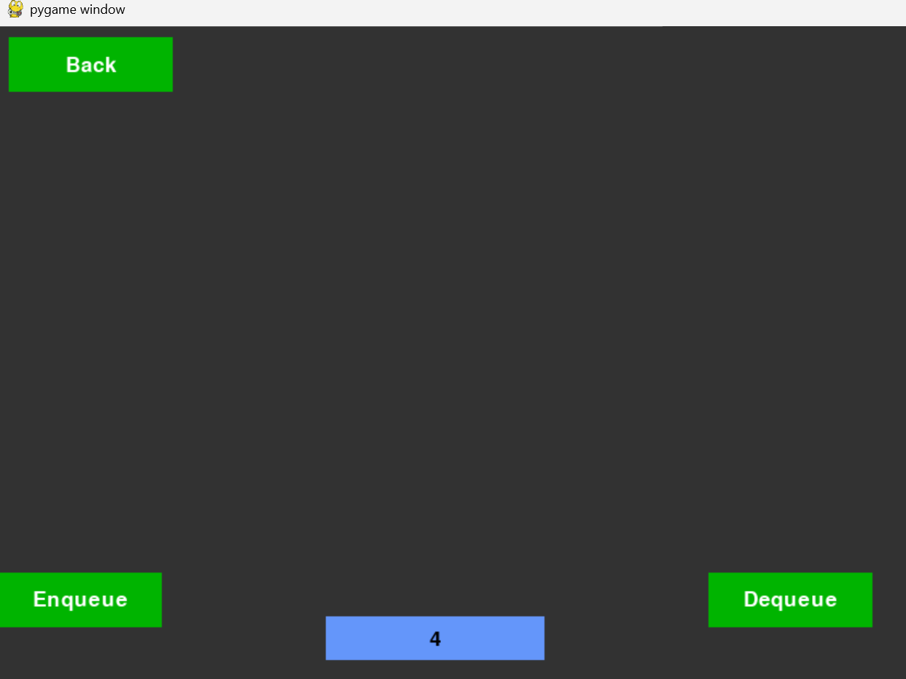

Python Unit Test (test_phase_1_queue):
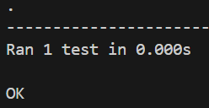

Test 3
Test Case | Description | Expected Result
Linked list inserted at position | Insert node with value 10 at position 2 | Node present in correct location in Linked List

Before: (Value 3 is currently at pos 2)
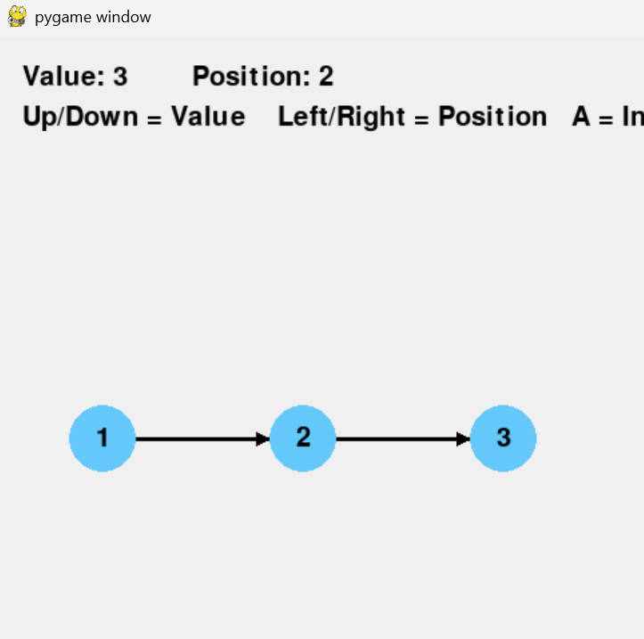

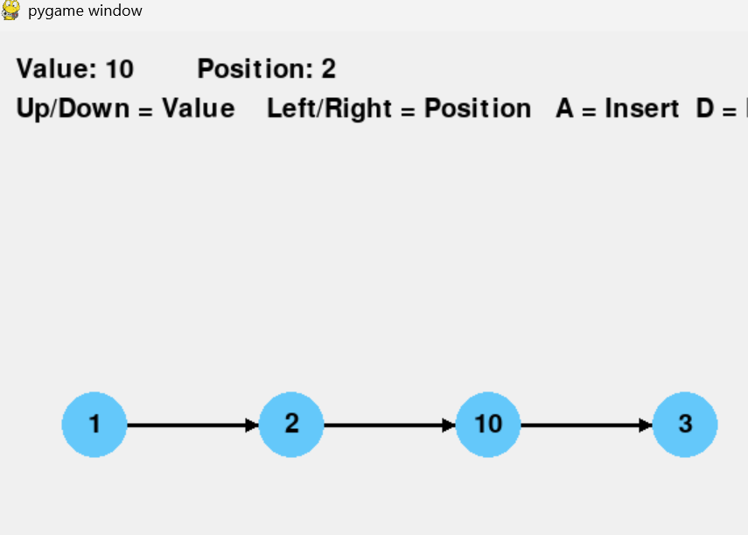
Before: (Value 10 is now at pos 2)

Python Unit Test (test_phase_1_LL):
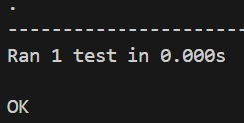

Test 4
Test Case | Description | Expected Result
BST insert and inorder traversal | Insert [50, 30, 70], and use inorder traversal | Traversal order: 30, 50, 70

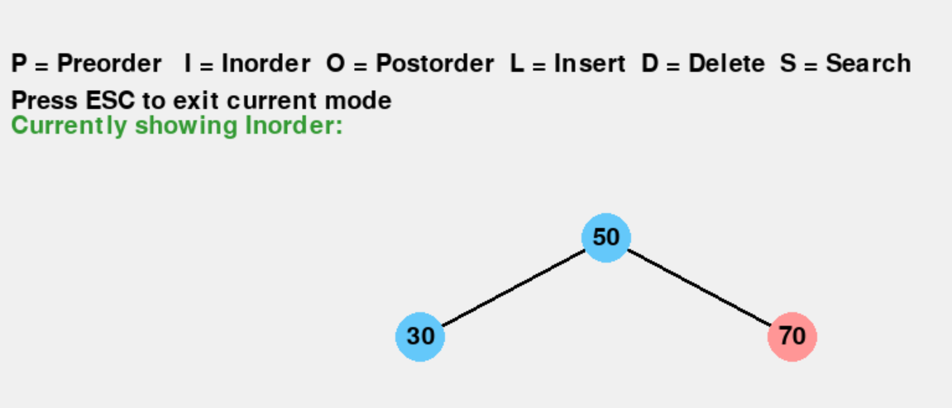

Python Unit Test (test_phase_1_BST):

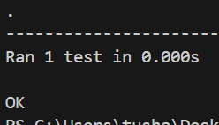

Test 5
Test Case | Description | Expected result
Bubble sort correctness | Sort array of [5, 3, 8, 1, 2] | Sorted array = [1,2,3,5,8]

Python unit test (bubbleSortTest)
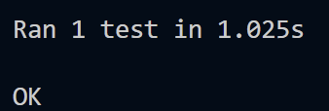

Test 6
Test case | description | Expected result
BFS click anywhere | Start can be any location | Traversal order can start from any location

Python results:
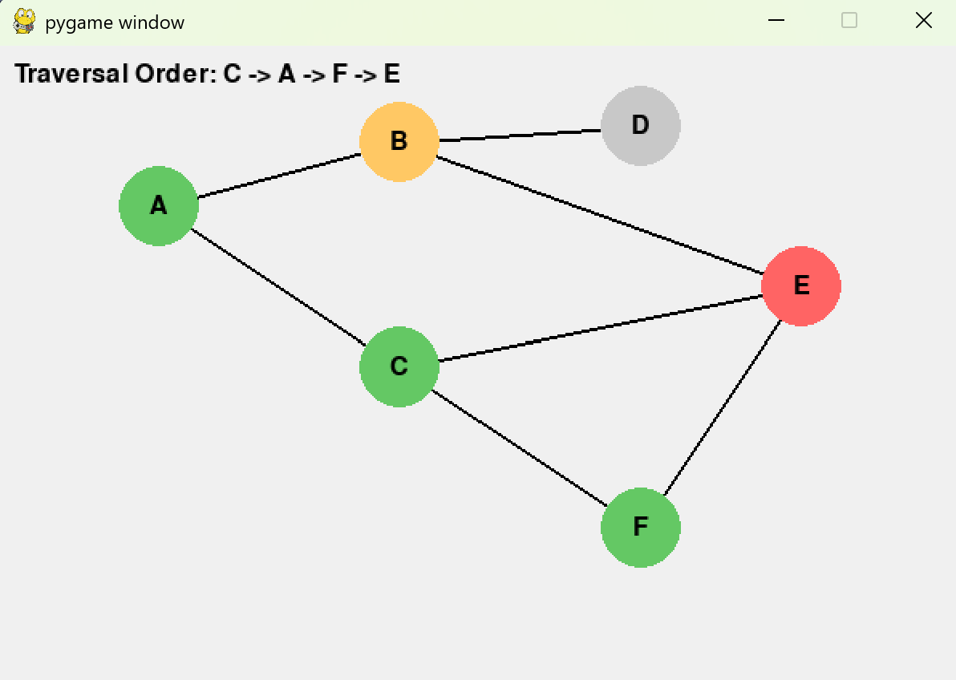
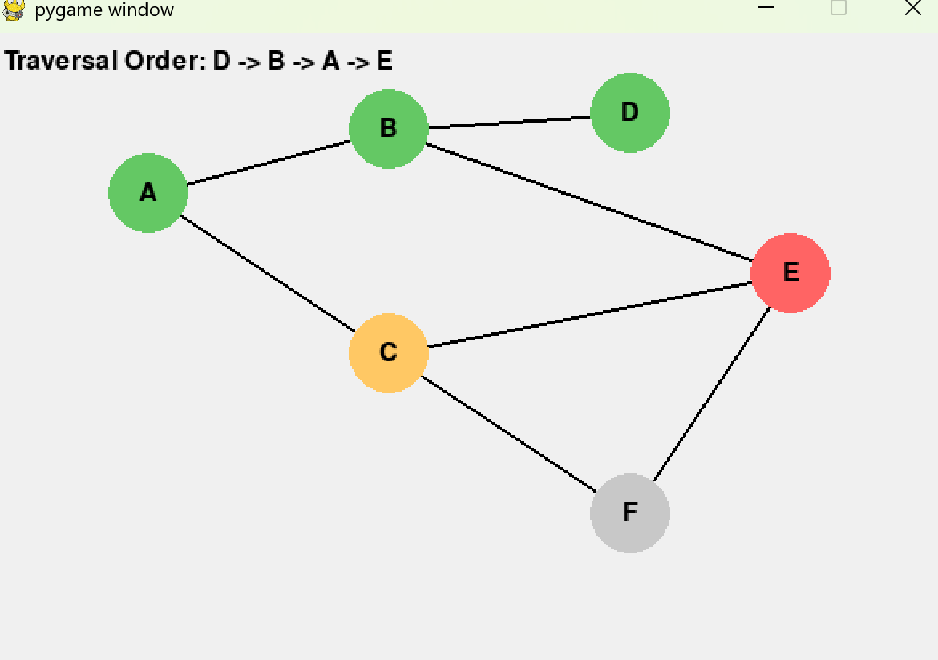

Phase 3: Test Cases

Test 1:
Test Case | Description | Expected Result
Obstacle avoidance for dynamic Dijkstra | Place walls between start and end | Path Routes around obstacles

Dynamic Puzzle:

Dijkstra puzzle:

Test 2:
Test Case | Description | Expected result
No valid path for dynamic Dijkstra | Completely block destination | Dynamic program states that their are 0 unique paths, and Dijkstra’s states that the path is inaccessible

Dynamic puzzle:

Dijkstra puzzle:

Test 3:
Test Case | Description | Expected Result
heap orderng | Inserts elements into the heap with different time and priority, same priority but different time. Then elements with the same  priority and time | orders the elements by priority, then time and then orders them by when they were inserted.

Different priority and time:

Same priority and different time:

Same priority and same time:

Refernces
Pygame (n.d.). Pygame Front Page — pygame v2.0.0.dev15 documentation. [online] www.pygame.org. Available at: https://www.pygame.org/docs/.

W3schools.com. (2026). W3Schools.com. [online] Available at: https://www.w3schools.com/python/ref_module_unittest.asp [Accessed 12 May 2026].
‌

